**K23-0593**

**Muhammad Ayesh**

**Lab-3**

**Task-1**

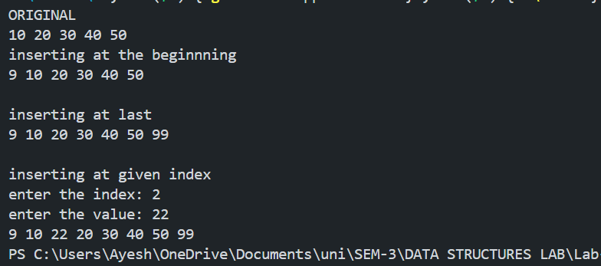

**Task-2**

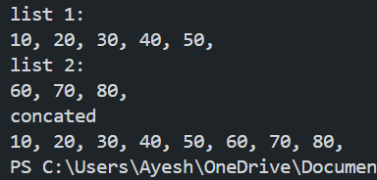

**Task-3:**

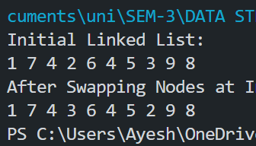

**Task-4:**

